**Day 3 – E-Mail Service**

1. Research the following internet protocols related to e-mail services.
   1. SMTP Protocol

Allows your PC to send mail

* 1. POP3 Protocol

Allows your PC to read mail

* 1. IMAP Protocol

Allows your PC to read mail

* 1. Web Mail

All mail stays on the server

Server provides a dynamic web site that you access through a web browser

1. Use the following resource as a starting point:  
   <https://askleo.com/what_is_pop_or_pop3_or_a_pop_account_and_what_about_smtp/>

1. Complete the following Venn Diagram to summarize your research.

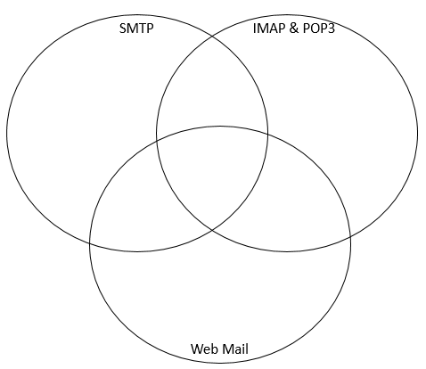

* Allows PC to send mail